**Week 6**

Ajax program

Screenshots:-

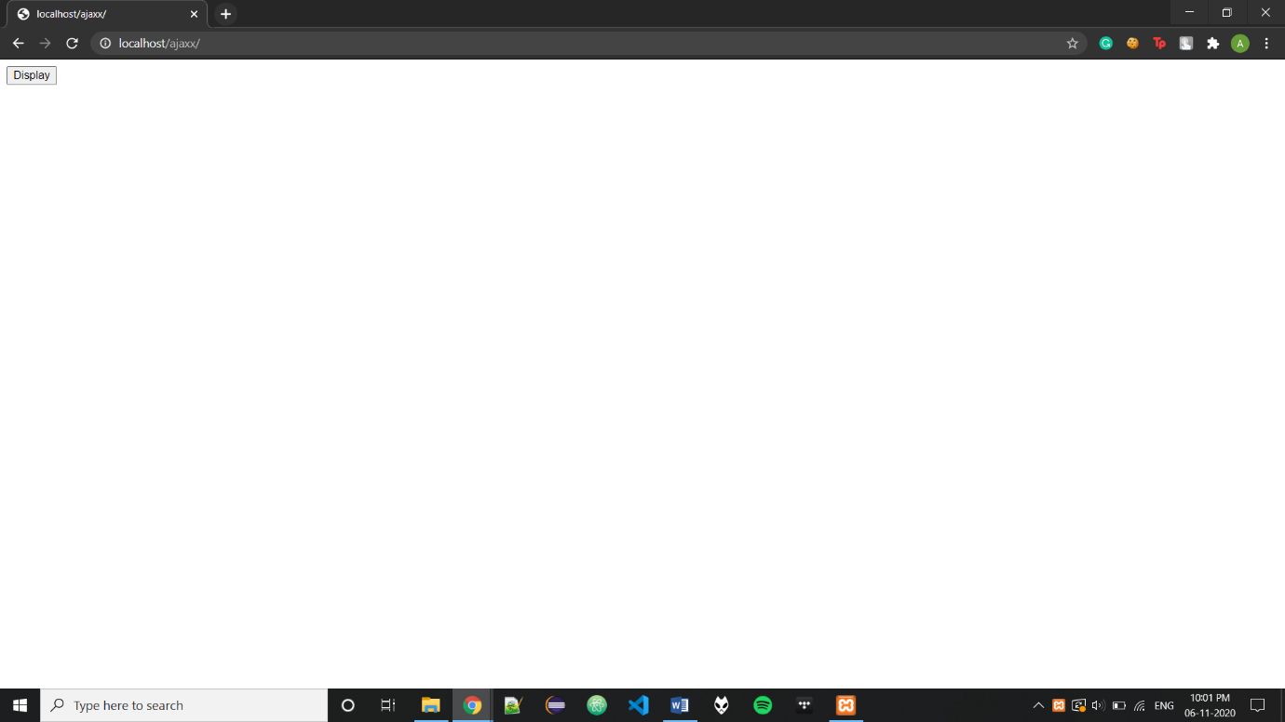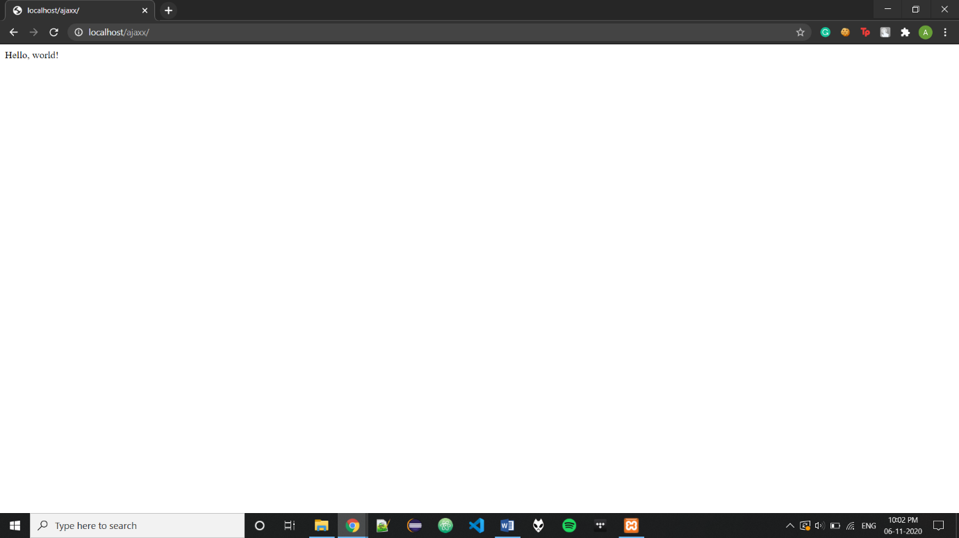

Code:-

<!DOCTYPE html>

<html>

<body>

<div id="dis">

<button type="button" onclick="load()">Display</button>

</div>

<script>

function load() {

var xhttp = new XMLHttpRequest();

xhttp.onreadystatechange = function() {

if (this.readyState == 4 && this.status == 200) {

document.getElementById("dis").innerHTML =

this.responseText;

}

};

xhttp.open("GET", "source.txt", true);

xhttp.send();

}

</script>

</body>

</html>

**Source.txt –**

Hello, world!